

**Faculty of Computing and IT**

**New Zealand Diploma in Web design & Development (Level 5)**

**ITC512:** [**IT4 2018 ITC511 Application, Testing and Maintenance (QT)**](https://blackboard.sit.ac.nz/webapps/blackboard/execute/courseMain?course_id=_46252_1)

**Queenstown Campus**

**Easy Appointments!**

**Tutor –**

**David Cartman**

Frequently Asked Questions

*1.What is Easy Appointments for?*

*2. How To add/edit customer details?*

*3. What type of things can we do in the calendar?*

*4.How to add/edit Services?*

*5. How to add/edit Categories?*

*6.What are Users?*

*7.How to create/edit users?*

*8.What Things you can do in General Settings?*

*9.What is Business Logic?*

*10.Is it possible to modify current user details?*

*11.Where to view your schedule?*

*12.Where to add secretary user?*

*13.How to add administrator user?*

*14.How to delete an appointment?*

*15.How many services can a Provider have?*

*16.Where to find and edit Legal Contents?*

*17.* *How to create an appointment from the Calendar?*

18. How to modify my Login credentials?

19. How to switch between providers at the calendar tab?

20. How do you check that all the information has been stored?

1. *What is easy appointments for?*

Easy appointments is a web application that allows customers and businesses to make appointments online.

1. *How to add/edit customer details?*

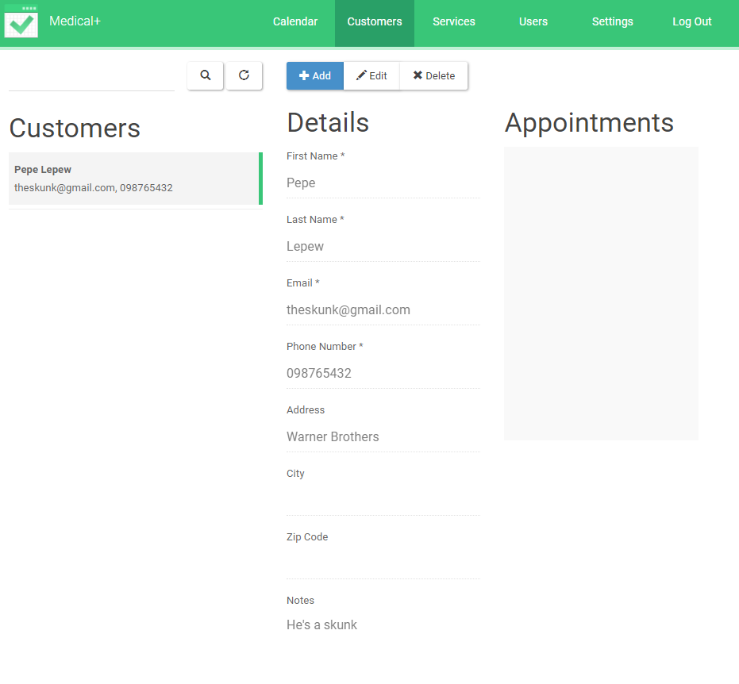Click on the customers tab, click on the +add button and fill in the details. Once you filled in the details click on the save button.

1. *What type of things can we do in the calendar?*

- Book appointments

- View customer details

- View appointment details

- Add a customer

*4.How to add/edit Services?*

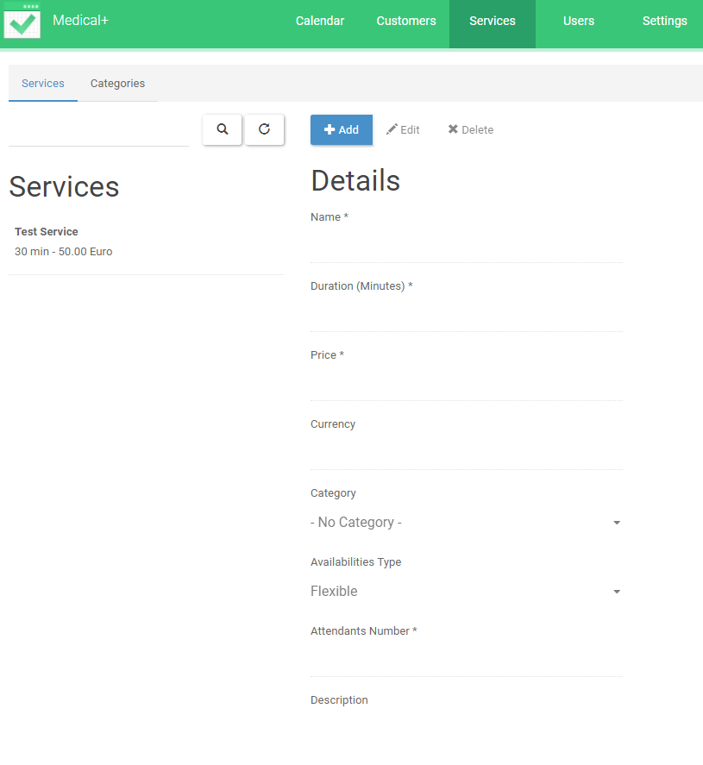Click on the Services tab, click on the +add button and fill in the details. Once you filled in the details click on the save button.

*5. How to add/edit Categories?*

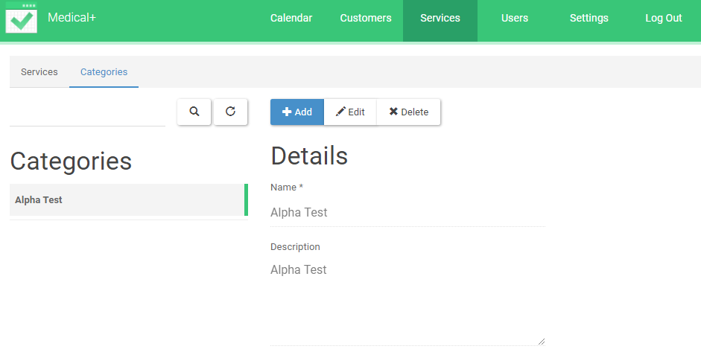Click on the Categories tab, click on the +add button and fill in the details. Once you filled in the details click on the save button.

*6.What are Users?*

The users are the Providers, Secretaries and Administrators. These people are the ones mainly using the web application from the backend.

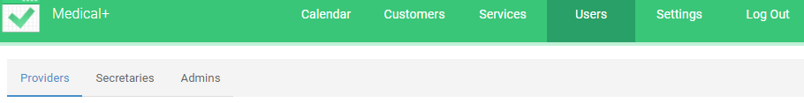

*7.How to create/edit users?*

Click on the Users tab, determine if you want to add a provider, secretary or admin, then click on the +add button and fill in the details. Once you filled in the details click on the save button.

*8.What Things you can do in General Settings?*

You can edit your company details like email and name of the company. Edit your Business schedule. Review business legal contents. Edit the current user details and what easy appointments is about.

*9.What is Business Logic?*

The business logic section is the schedule for the week. You can modify the working time of the week like the start and end, also the breaks between appointments. How much time a customer needs to book or re arrange their appointment.

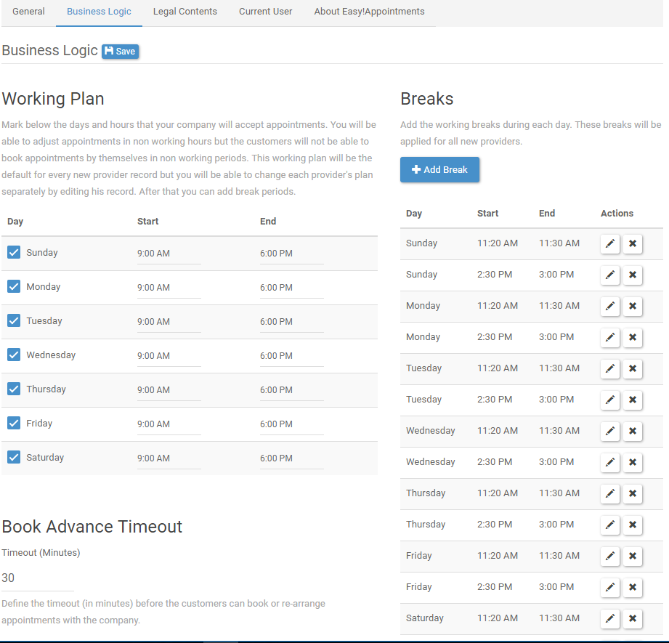

*10.Is it possible to modify current user details?*

**Yes**, by clicking on the settings Tab, and click on the current user tab, once you’re their click on the details you want to change.

*11.Where to view your schedule?*

Click on the Calendar tab if you’re not in it already, then you should be able to see your schedule for this week and if you want to see your schedule for the month just click on the month button on the top right-hand corner of the calendar.

*12.Where to add secretary user?*

Click on the Users tab, then click on the secretaries’ tab then click on the +add button and fill in the details. Once you filled in the details click on the save button.

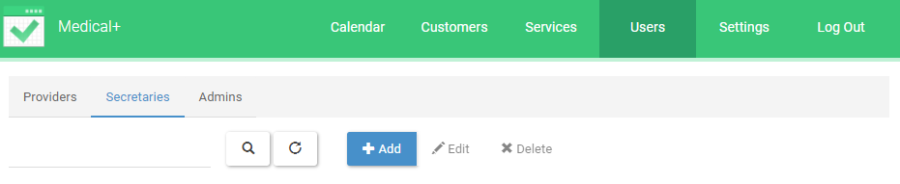

*13.How to add administrator user?*

Click on the Users tab, then click on the administrator’s tab then click on the +add button and fill in the details. Once you filled in the details click on the save button.

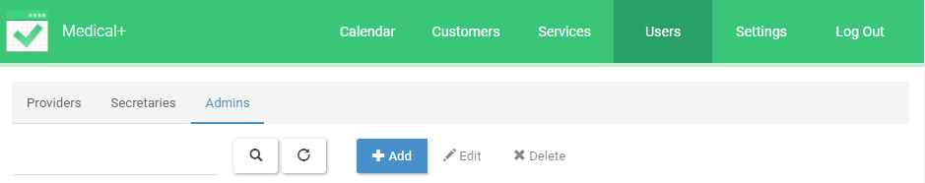

*14.How to delete an appointment?*

Click on the calendar’s tab and then select the appointment you want to delete in the calendar, it should come up with the details at the bottom of it will be a delete button.

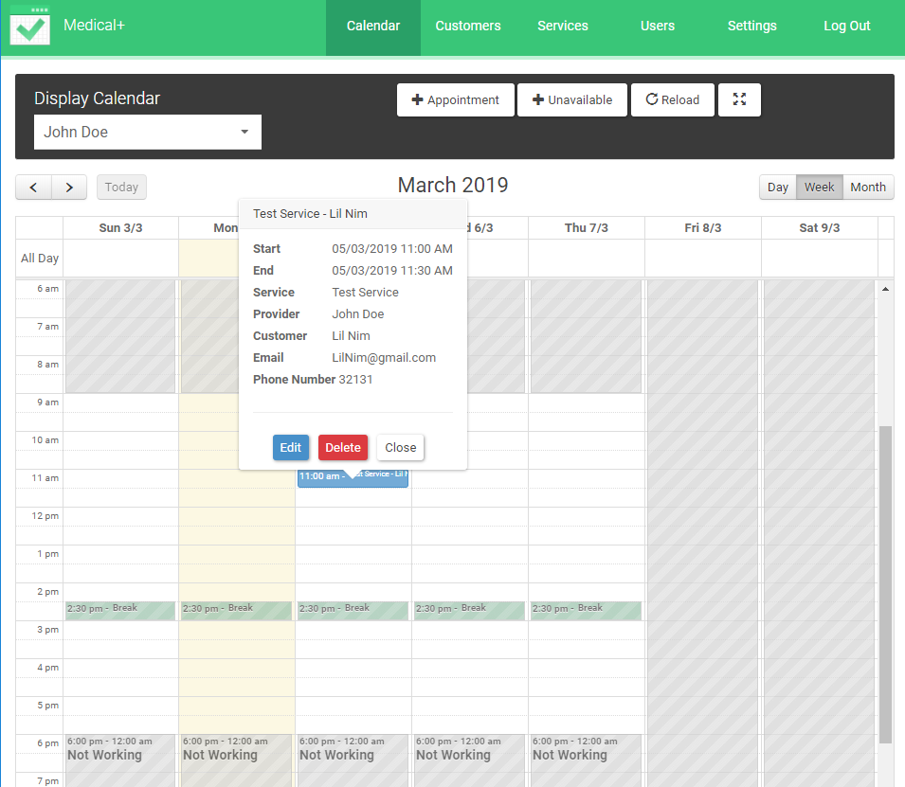

*15.How many services can a Provider have?*

As many as the provider wants.

*16.Where to find and edit Legal Contents?*

By clicking on the Settings tab, then click on the Lecal Content tab and once you are there you can click on the content you want to modify such as: Cookie Notice, Terms & Condition and Privacy Policy

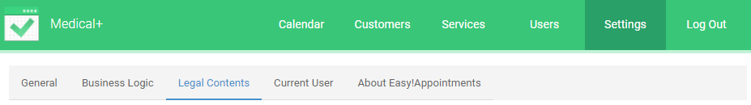

*17.* *How to create an appointment from the Calendar?*

Click on Calendar tab, then click on the +Appointment button and fill all the information.

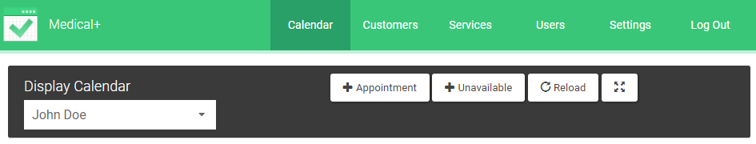

18. How to modify my Login credentials?

Click on the Settings tab and then go to Current user. Now you should be able to change the details about your login credentials at the right.

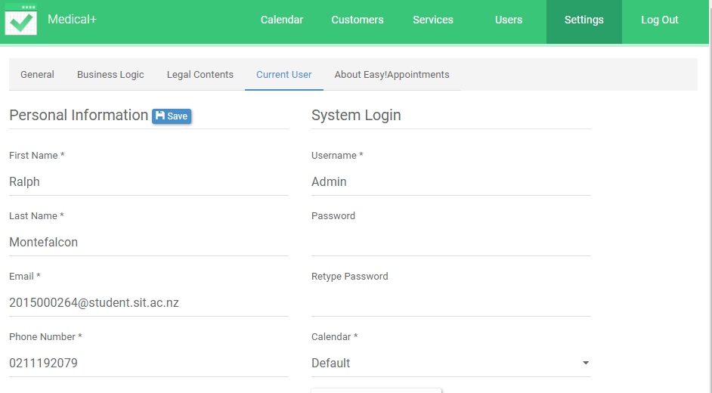

19. How to switch between providers at the calendar tab?

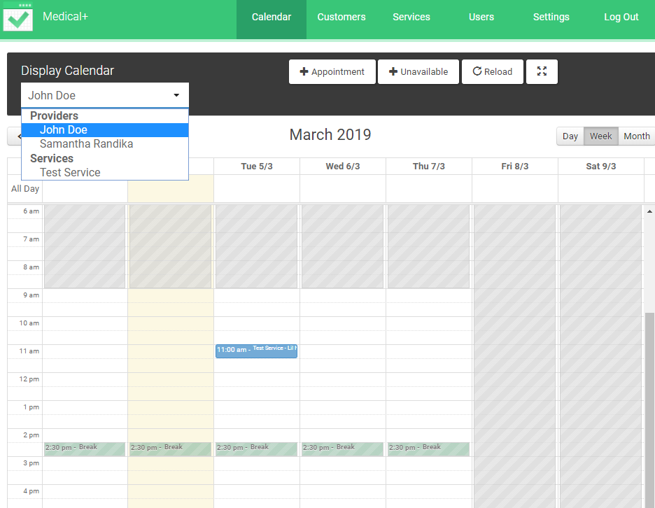 Click on the Calendar at the top of the Calendar their should be a drop down just below Display Calendar and then you can select which provider’s schedule you want to see.

20. How do you check that all the information has been stored?

Go to your phpMyAdmin, login and once you are there you will be able to see all the changes you have done on the Easy Appointments web application.

